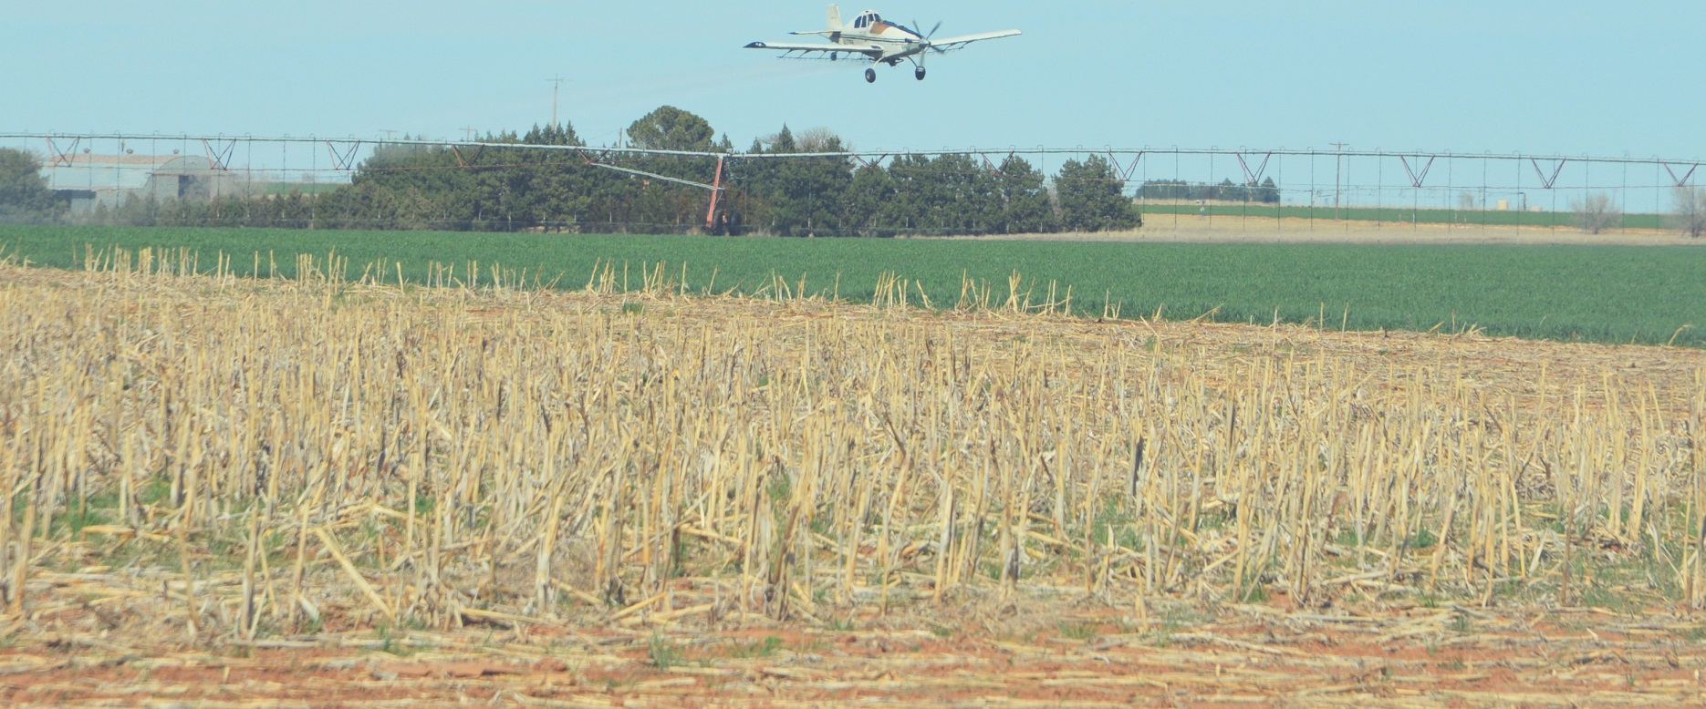
HIGH PLAINS
Ag Conference

C E U ' S I N
O N E DA Y !
5

DECEMBER 8, 2017
8:30 a.m. to 3:00 p.m.
Texas A&M AgriLife Research Center
1102 E. FM 1294, Lubbock
TDA APPROVED CEU'S – 1 HR. IPM, 1 HR. L&R, 3 HR. GENERAL

$35 per person w/ lunch included if Pre-Registered by Dec 6th

$45 at the door with no lunch guarantee

Follow us on Facebook and Twitter
@LbkAgriLifeExtension @LubbockAgriLife

For more information contact Robert Scott,
806-775-1740 rj-scott@tamu.edu
Individuals with disabilities who require an auxiliary aid, service or accommodation in order to participate in Extension sponsored meetings are encouraged to contact
the County Extension Office at 775-1740 to determine how reasonable accommodations can be made.
Texas A&M AgriLife Extension provides equal opportunities in its programs and employment to all persons, regardless of race, color, sex,
religion, national origin, disability, age, genetic information, veteran status, sexual orientation, or gender identity.
The Texas A&M University System, U.S. Department of Agriculture, and the County Commissioners Courts of Texas Cooperating

Detach and mail Pre­Registration to:
Lubbock County Extension, PO Box 10536, Lubbock, TX 79408
Make checks Payable to "LLC"

Name:______________________________________________________________________

Ph. Number:_________________________________________________________________

Email:______________________________________________________________________

